ASSIGNMENT-7.4

H. NO:2303A51685

BATCH-13

Task 1: Debugging a Recursive Calculation Module Scenario
You are maintaining a utility module in a software project that performs mathematical computations. One function is meant to calculate the factorial of a number, but users are reporting crashes or incorrect outputs.

Task Description
You are given a Python function intended to calculate the factorial of a number using recursion, but it contains logical or syntactical errors (such as a missing base condition or incorrect recursive call).
Use GitHub Copilot or Cursor AI to:
- Analyze the faulty code
- Identify the exact cause of the error
- Suggest and apply corrections to make the function work correctly
Document how the AI detected the issue and what changes were made.

Expected Outcome
- A corrected recursive factorial function
- AI-generated explanation identifying: o The missing or incorrect base case o The corrected recursive logic
- Sample input/output demonstrating correct execution
- #prompt:
given a Python function intended to calculate the factorial of a number using recursion.

#ERROR CODE:
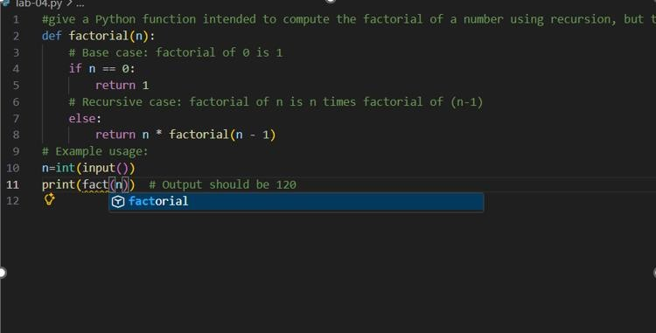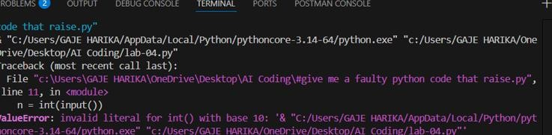

#CORRECT CODE
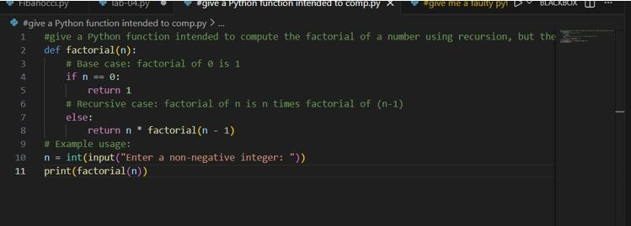

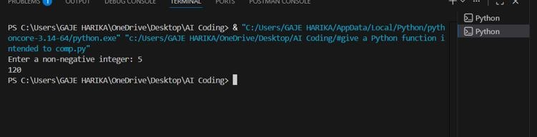
JUSTIFICATION:
The error occurred because the input() function received an invalid string instead of a numeric value. This happened due to the IDE execution method passing the Python run command as input. As a result, int() raised a ValueError. Additionally, the function was incorrectly invoked using a different name than its definition. Both issues were resolved by running the program through the terminal and using the correct function name.

Task 2: Fixing Data Type Errors in a Sorting Utility Scenario
You are developing a data processing script that sorts user input values.
The program crashes when users enter mixed data types.

Task Description
You are provided with a list-sorting function that fails due to a TypeError caused by mixed data types (e.g., integers and strings).
Use GitHub Copilot or Cursor AI to:
- Detect the root cause of the runtime error
- Modify the code to ensure consistent sorting (by filtering or type conversion)
- Prevent the program from crashing
Explain the debugging steps followed by the AI.

Expected Outcome
- A corrected sorting function
- AI-generated solution handling type inconsistencies
- Successful sorting without runtime errors
- Explanation of how the fix improves robustness

#PROMPT
#Analyze the given Python list-sorting code that crashes due to mixed data types (integers and strings), identify the TypeError cause, modify the function to handle type inconsistencies using filtering or type conversion, prevent runtime crashes.

#ERROR CODE
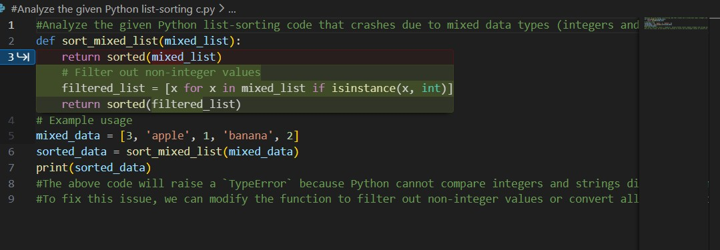

#CORRECTED CODE
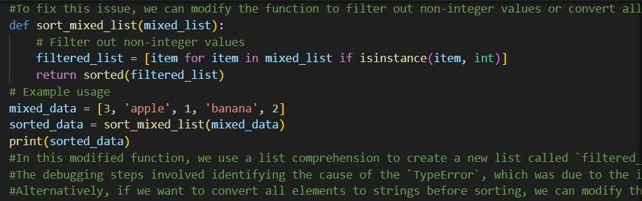

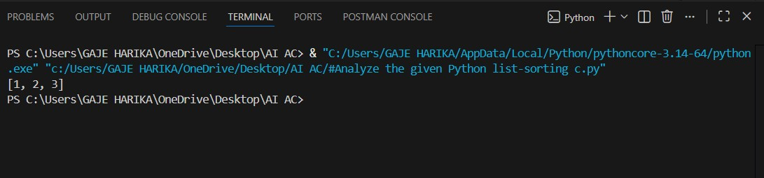
#JUSTIFICATION:
The error occurs because Python cannot sort a list containing both integers and strings. When the sorted() function tries to compare different data types, it raises a TypeError. To fix this, the list is filtered to include only integers before sorting. This prevents the program from crashing. The fix improves robustness by safely handling mixed data types.

Task 3: Improving File Handling Reliability Scenario
A backend script reads data from files regularly. Over time, the system shows performance issues due to improper resource management.

Task Description
You are given a Python file-handling snippet that opens a file but does not explicitly close it.
Use GitHub Copilot or Cursor AI to:
- Identify the potential problem in the code
- Refactor it using best practices (such as a context manager)
- Ensure safe and reliable file handling
Briefly describe why the revised approach is better.

Expected Outcome
- Refactored code using the with open() statement
- AI explanation highlighting prevention of resource leaks
- Clean execution without warnings or errors

PROMPT:
#Analyze the given Python file-handling code that opens a file without closing it, identify the resource management issue, refactor it using the with open() context manager, and briefly explain how this improves reliability and prevents resource leaks.

#ERROR CODE
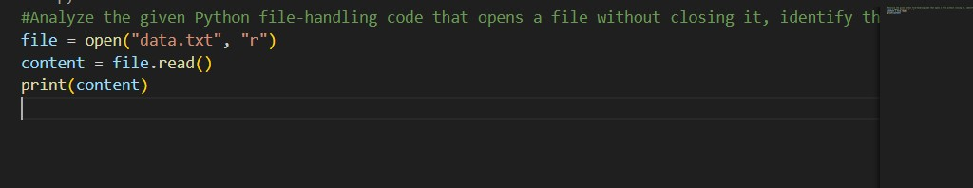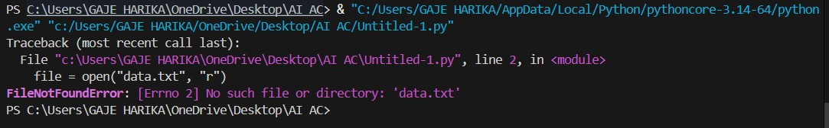
#CORRECTED CODE:
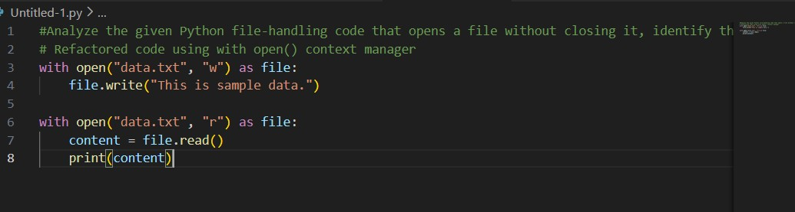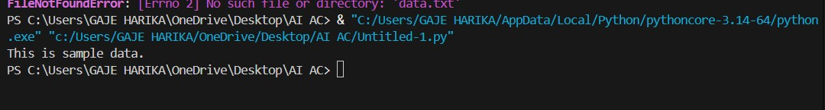
JUSTIFICATION:
The initial code opened a file without closing it, which can lead to resource leaks and performance issues. It also raised a FileNotFoundError because the file did not exist in the directory. The corrected code uses the with open() context manager, which safely opens and automatically closes the file after use. Writing to the file first ensures the file exists before reading, making the program reliable and error-free.

Task 4: Handling Runtime Errors Gracefully in Loops Scenario
You are working on a data analysis script that processes a list of values. Some values cause runtime errors, but the program should continue processing remaining data.

Task Description
You are provided with a code snippet containing a ZeroDivisionError inside a loop.
Use GitHub Copilot or Cursor AI to:
- Detect the exact location of the error
- Add appropriate exception handling using try-except
- Ensure the loop continues executing safely
Document how AI improved the fault tolerance of the program.

Expected Outcome
- Updated code with proper exception handling
- Meaningful error messages instead of program crashes
- Successful execution for all valid inputs
#PROMPT:
#Analyze the given Python loop code that raises a ZeroDivisionError,add try-except handling so the loop continues executing,
#ERROR CODE:
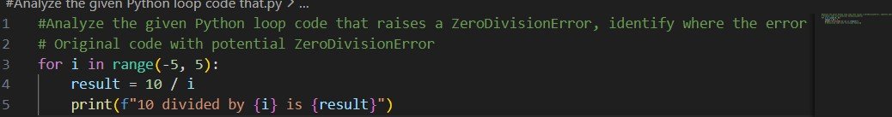

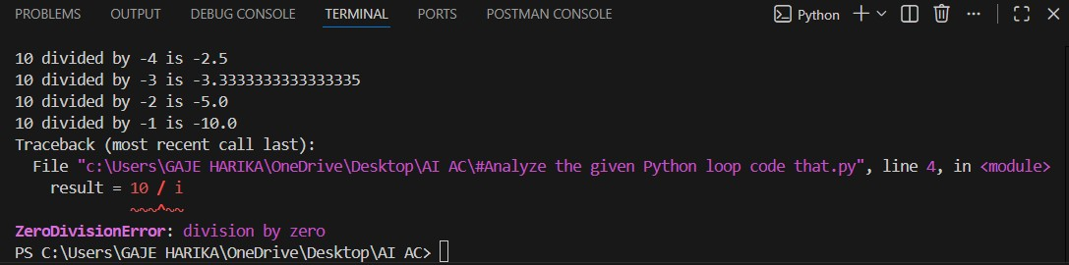

#CORRECT CODE
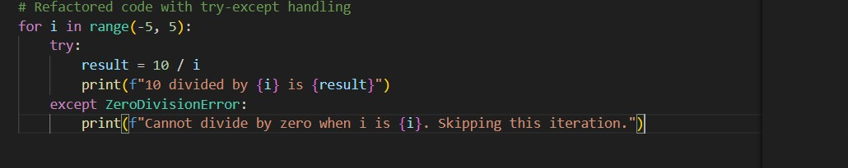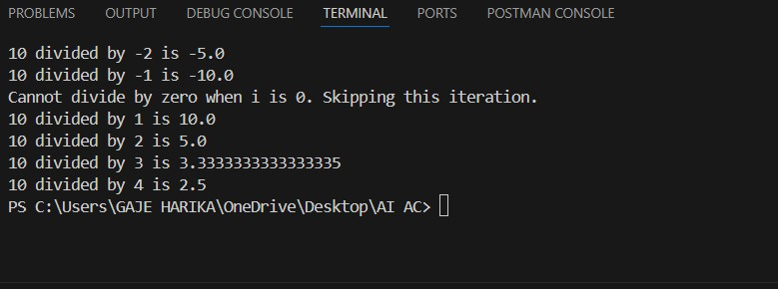
#JUSTIFICATION:
In the original code, a ZeroDivisionError occurs when `i` is 0, as dividing by zero is undefined in mathematics. This causes the program to crash and prevents any further iterations of the loop from executing
In the refactored code, we wrap the division operation in a try-except block. If a ZeroDivisionError occurs (when `i` is 0), the except block catches the error and prints a meaningful error message instead of crashing the program. This allows the loop to continue executing for the remaining values of `i`, improving fault tolerance and ensuring that the program can handle unexpected situations gracefully without terminating abruptly.

Task 5: Debugging Class Initialization Errors Scenario
A class written by a junior developer is throwing unexpected errors when
objects are created or attributes are accessed.

Task Description
You are given a Python class with:
- Incorrect __init__ parameters
Missing or incorrect attribute references (e.g., missing self) Use GitHub Copilot or Cursor AI to:
- Analyze the class definition
- Identify constructor and attribute issues
- Correct the class so objects initialize and behave correctly Explain the corrections suggested by the AI.

Expected Outcome
- A corrected class definition
- Proper use of self and constructor parameters
- AI-assisted explanation of the original errors and fixes
- Sample object creation and method usage
#PROMPT:
Analyze the given Python class that has errors in the __init__ method and missing or incorrect use of self, identify the constructor and attribute issues, correct the class definition, and explain how the fixes allow proper object creation and usage.

#ERROR CODE
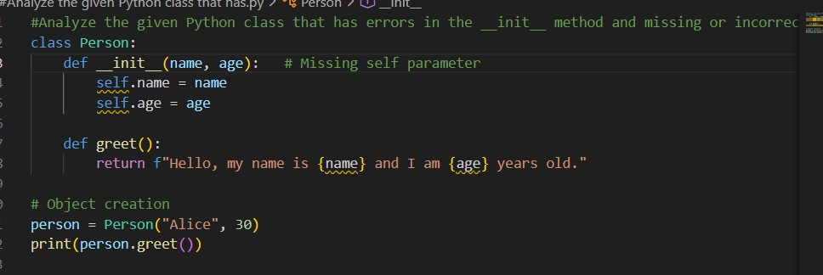

#CORRECT CODE
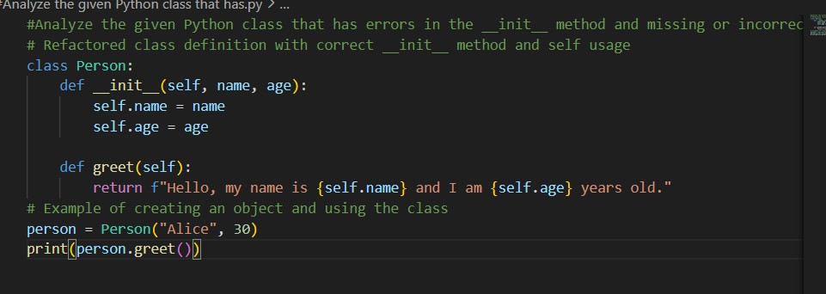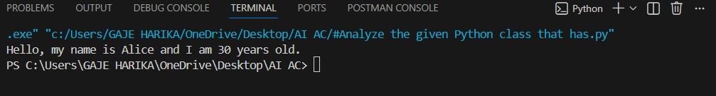

JUSTIFICATION
The original class contained errors because the __init__ and greet methods were missing the self parameter, which is required to access instance variables. Due to this, object creation and attribute access failed. The corrected class properly uses self to initialize and reference attributes. This fix allows objects to be created successfully and methods to work without errors.

